**MEMORANDUM**

**TO:** All Chief Fiscal Officers

All Payroll and Personnel Officers

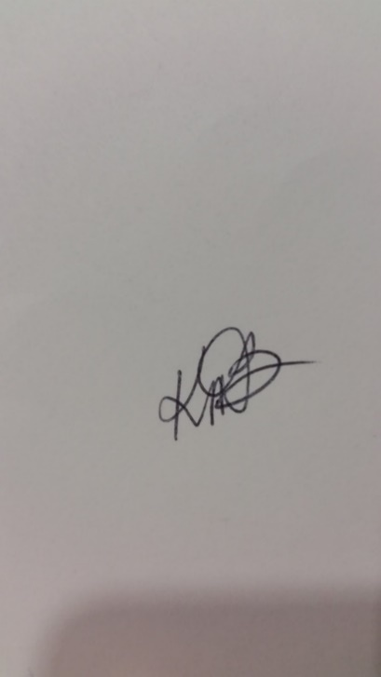

**FROM:** Kathleen D. Baxter

State Comptroller

**DATE:** October 16, 2024

**RE:** Taxation and Reporting Personal Use of State Owned/Leased Vehicles

In accordance with IRS regulations, the total value of the personal use of state owned/leased vehicles is taxable for federal, state, and FICA purposes and must be reported on the employee’s Form W-2. Since the State of Alabama has a written policy prohibiting any personal use of an employer-provided vehicle other than for commuting purposes (Section 36-25-5, *1975 Code of Alabama*), the State elects the commuting valuation rule of $3.00 per day for employees who earn less than $180,000 annually and are not elected officials. Employees who are paid $180,000 or more annually, or are elected officials, are considered “control employees”. The only options available to control employees are (1) the lease value rule or (2) the vehicle cents-per mile valuation rule. In accordance with IRS, the cents-per-mile valuation method is applicable for employer provided vehicles first made available for use in the calendar year 2024 with a maximum value of $62,000 for passenger automobiles and $62,000 for trucks or vans (Refer to *IRS publication 15b* for 2023 values).

FICA and Medicare tax must be computed on the value of this personal use, matched, and paid by the department. This will require the Comptroller to calculate and collect the required FICA and Medicare tax due on the affected employees’ payroll checks before issuing a Form W-2 to employees. It is mandatory that employees be notified within 30 days after being provided a vehicle of the effect this benefit may have on withholdings. The employee’s share of FICA and Medicare will be withheld from the employee’s payroll check. The State’s share of FICA and Medicare tax will be charged to the payroll fund(s) designated in GHRS for the employee. The charge will be reflected on the department’s fringe benefit payroll journal voucher. Departments will receive detail listings supporting this charge in December 2024.

The data required to accurately report and compute taxes due on this fringe benefit must be provided by all State departments no later than November 22, 2024. The $3 per day charge for commuting use of State owned/leased vehicles is reported for the period November 1, 2023 - October 31, 2024. The State of Alabama selected the IRS option to cut off calculation for taxable fringe benefits on October 31 of any tax year. The data required for that period for each employee is the total number of days the vehicle was used for commuting purposes.

For control employees who are required to use the lease value rule, information can be found on the IRS website at <https://www.irs.gov/pub/irs-pdf/p15b.pdf>. For control employees who opt to use the vehicle cents-per-mile method, please use the Cents-Per-Mile computation worksheet [FRMS-16CPM “Control Employees 2024”](https://comptroller.alabama.gov/wp-content/uploads/2024/10/FRMS-16-CPM-Control-Employees-2024.xls). Please use the Excel workbook FRMS-16 for employees using the $3.00 per day commuting valuation rule. The [FRMS-16 “Commuting Use of State Owned/Leased Vehicles”](https://comptroller.alabama.gov/wp-content/uploads/2024/10/FRMS-16-workbook-2024.xls) form will do the computations for you and is in the exact format required by this office for non-control employees. The Excel version of both worksheets can be found on our website at [www.comptroller.alabama.gov](http://www.comptroller.alabama.gov) under “Reports and Forms, Online Forms”. The forms may also be printed and filled out manually. The FRMS-16 workbook is set up with 6 pages/tabs to accommodate the listing of up to 294 employees. Only the page(s) with data should be sent to Payroll. Be sure to include a contact name and phone number for your department on the first page as well as the department head signature. If you have employees that are not paid by your agency but are paid by another agency, you will need to coordinate with the paying agency to make sure the commuting use is reported by the paying agency.

It is imperative that the information reported is accurate. Ensure that all vehicles used for commuting are reported except those specifically exempted by IRS. Vehicles, either marked or unmarked, that are used for law enforcement functions are exempt from reporting. If your department owns no State vehicles or no commuting occurs, return the form marked "NO VEHICLES".

The personal use of employer-provided aircraft is also taxable for federal, state, and FICA purposes and must be reported on Form W-2. Specific valuation rules in assessing the personal use of a flight on an employer-provided aircraft must be used in determining this taxable value. If your department has an employee who has used an employer-provided aircraft for personal reasons, contact this office for the valuation rules and additional instructions.

In addition to the data required for the period ending October 31, 2024, those employees who drive state owned vehicles and terminate State service between November 1, 2024, and October 31, 2025, must submit interim data from November 1, 2024, through the termination date immediately upon notice of termination and prior to the issuance of their last payroll warrant.

It is imperative that all departments return this form by November 22, 2024. Failure to return this form may result in a delay of processing payroll data and the issuance of Form W-2's for your department.

For questions, please contact the Payroll hotline at (334) 242-2188.

KDB/ds