Registrar Travel Form Instructions

Name of the County at the top of the form
Name of Registrar (please print)
Home address of Registrar
Your Home Base/Official Co Courthouse (the City where the official Courthouse is located)
Mark if you were the driver or passenger in the vehicle

Departure from Base:

Month and date
Enter point of Departure and Destination (this should be the name of the city in both)
Number of miles traveled
Enter the time of departure from your base
Enter amount of per diem if applicable

Upon Return to base:

Month and date
Enter point of Departure and Destination (this should be the name of the city in both)
Number of miles traveled
Enter the time that you return to your base
Enter amount of per diem if applicable

If this travel requires you to stay multiple days, each day of your stay should be listed on your travel claim. For a day where no mileage is claimed you should list the month/date and enter the city name in both the “point of departure” and “place of destination”, and any per diem on the travel form. See example:

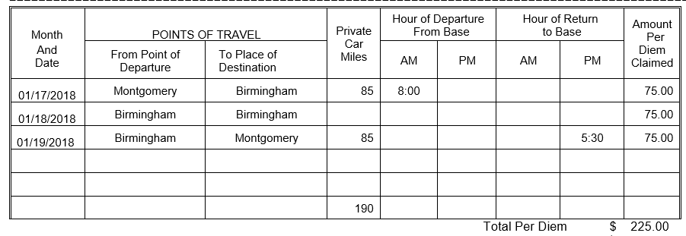

The travel form must be signed by the Board of Registrar member. It is desirable that travel claims are submitted as soon after the travel occurred as possible. Within a 2-4-week period is reasonable. If the signature is not legible, the traveler must print their name below the signature. The hour of departure from your base and the hour of return to base should be shown on the travel expense form. The traveler is ONLY entitled to per diem if they are away from base for six hours or more (See below for rates). These times should be notated in the standard time format, not military time. For travel related expenses, your base is defined as a city or town.

- Per Diem Allowance

The guidelines for travel reimbursements are established by state law as follows (Code of Alabama 1975, §36-7-20 through 36-7-23, as amended).
The term overnight, as used in Code of Alabama 1975, §36-7-20, as amended, means exactly what the word implies. The common law meaning of night usually means the period between sunset and sunrise. Another rule often applied is that night is defined as beginning thirty minutes after sunset and ending thirty minutes before sunrise. “Overnight” implies that a period of rest is needed to meet the demands of work while away from home. Travelers within reasonable travel distance from their home or base are expected to return to their home or base. For travel related expenses, your base is defined as a city or town. Individual circumstances will determine what is reasonable, but generally, a trip of 100 miles or less one-way does not require an overnight stay.

"[T]he amount allowable to a person traveling inside the State of Alabama, in the service of the state or any of its departments, institutions, boards, bureaus, commissions, councils, committees, or other like agencies for expenses other than transportation may be fixed by the Governor at not less than seventy-five dollars ($75) per day, and this amount shall be uniform in operations as to all persons traveling within the state on official business.” (Code of Alabama 36-7-20(a))

The current allowance for overnight per diem is $75.00.

For travel requiring an overnight stay, the traveler may be paid the current daily reimbursement rate for each full day and portion of a day, for the duration of travel (Attorney General's Opinions issued August 1, 1972, October 8, 1975, and October 30, 1979).

Under no circumstances will an employee be paid an overnight travel allowance at the official station or base or primary residence. For travel related expenses, your base is defined as a city or town. If state business requires the traveler to be away from the base or official station on weekends or holidays, the traveler will be entitled to reimbursement for travel for those days. Rev. 07/2017 State of Alabama Fiscal Policy and Procedures Manual Page 57

If the individual's travel is interrupted for personal convenience, the travel allowance may not exceed the costs that would have been incurred for authorized uninterrupted travel. Per AG Opinion 89-00371, this applies to mileage and per diem. The mileage claimed can only be the amount claimed had the traveler left and returned to their base.

No travel allowance shall be paid for a trip of less than six hours’ duration. For travel that does not require an overnight stay, the traveler shall be paid a meal allowance of $11.25 (15% of the regular per diem rate) for a trip of six to twelve hours' duration. For travel in excess of twelve hours' duration, the traveler shall be paid $30.00, which represents one meal allowance and one-fourth of the per diem allowance.
No meal allowance will be paid if the traveler remains in the city where his/her home or base is located. For travel related expenses, your base is defined as a city or town.

If a meal is provided, the traveler may not claim a meal allowance. AG Opinion 88-00340.

b. Reimbursement For Mileage Expenses

Effective January 1, 2018, persons traveling on official business for the state or any of its departments, institutions, boards, bureaus, commissions, councils, committees, or other like agencies in privately owned vehicles shall receive $.545 per mile in lieu of their actual expenses for transportation. Officers and employees of the state are entitled to mileage allowance from their base to destination and return or for miles actually traveled from home to destination and return, whichever is less. For travel related expenses, your base is defined as a city or town.

Mileage is to be reported in whole miles, rounded to the nearest whole number. To calculate the amount to be reimbursed, all mileage listed on the travel form must be totaled and then multiplied by the applicable rate. The reimbursement rate for mileage expenses is equal to the mileage rate allowed by the Internal Revenue Code for income tax deductions.

For the complete set of travel policies, please go to www.comptroller.alabama.gov, choose “procedures”, Fiscal Policy & Procedures”, Fiscal Policy and Procedures with bookmarks” and look in Chapter 6. All travel rules and laws are in this section and apply to anyone that travels in the service of the state.

Required Receipts

Receipts and/or proof of payment are required to support the following expenses, except when the disclosure of the identity of the traveler would be detrimental to the State's interest:
Registration fees - include itemized breakdown, if applicable.
Travel related fees such as parking, toll and/or taxi fees with notation of “to” and “from”.
Miscellaneous expenses. Receipts must be itemized and conform to the requirements of Purchasing (Section 6-5, B)

